**Requirement Gathering and Analysis Phase**

**Solution Architecture**

|  |  |
| --- | --- |
| Date | 05-07-2024 |
| Team ID | PNT2022TMIDxxxxxx |
| Project Name | Project – Web Grocery App |
| Maximum Marks |  |

**Solution Architecture: For Web Grocery App**

Solution architecture is a complex process with many sub-processes that bridges the gap between business problems and technology solutions. Its goals are to:

**1. Finding the Best Tech Solution to Solve Existing Business Problems**

For a web grocery app, the primary business problems may include the need for efficient inventory management, secure transactions, user-friendly shopping experiences, and reliable delivery tracking. The best tech solutions to these problems involve:

* **Inventory Management Systems**: Implementing a real-time inventory management system that tracks stock levels, updates product availability, and alerts for restocking.
* **Secure Payment Gateways**: Integrating secure payment gateways like Stripe or PayPal to ensure safe and smooth transactions.
* **User Experience Design**: Designing an intuitive user interface with features like advanced search, product filtering, and easy navigation to enhance the shopping experience.
* **Delivery Management**: Implementing a delivery tracking system that provides real-time updates on order status and estimated delivery times.

**2. Describing the Structure, Characteristics, Behavior, and Other Aspects of the Software to Project Stakeholders**

To ensure all stakeholders understand the project's scope and goals, the architecture should be clearly defined and documented. This includes:

* **System Architecture Diagram**: A visual representation of the system's architecture, including servers, databases, APIs, and front-end components.
* **Characteristics**: Defining key characteristics such as security measures, performance benchmarks, and user interface guidelines.
* **Behavior**: Describing how the system behaves under different scenarios, such as peak usage times, transaction processing, and data synchronization.
* **Documentation**: Providing comprehensive documentation that includes use cases, user stories, and technical specifications.

**3. Defining Features, Development Phases, and Solution Requirements**

A well-defined roadmap outlines the features, development phases, and requirements necessary to bring the grocery web app to life:

* **Feature List**: Detailed description of features like user registration, product catalog, shopping cart, checkout process, payment integration, and order tracking.
* **Development Phases**: Breaking down the project into phases such as initial planning, prototyping, development, testing, deployment, and maintenance.
* **Requirements**: Clear definition of functional and non-functional requirements, including performance metrics, security protocols, and usability standards.

**4. Providing Specifications According to Which the Solution is Defined, Managed, and Delivered**

Specifications ensure the project is developed according to the agreed-upon standards and guidelines:

* **Technical Specifications**: Detailed technical requirements, including programming languages, frameworks, databases, and third-party services to be used.
* **Design Specifications**: Wireframes, mockups, and design prototypes that guide the visual and user experience design of the app.
* **Management Specifications**: Project management methodologies (e.g., Agile, Scrum) to be followed, including timelines, milestones, and deliverables.
* **Delivery Specifications**: Guidelines for deploying the app, including staging environments, continuous integration/continuous deployment (CI/CD) pipelines, and post-deployment monitoring.

**Example - Solution Architecture Diagram:**

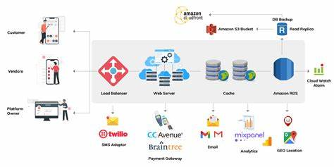

Figure 1: Architecture and data flow of the web grocery app